Participants: Omesh S, Aatif Mohammed.S, Yaqub Ahmed, Pamela Espinoza M., Abhishek Haris, Ivan P

Class Diagram:

Problem:

* Incorrect use of arrows in the class diagram. (Arrows show relationships like inheritance or association. Current arrows are unclear)

Solution: Resolved the use of arrows to be more defined and accurate to their relationship with one another

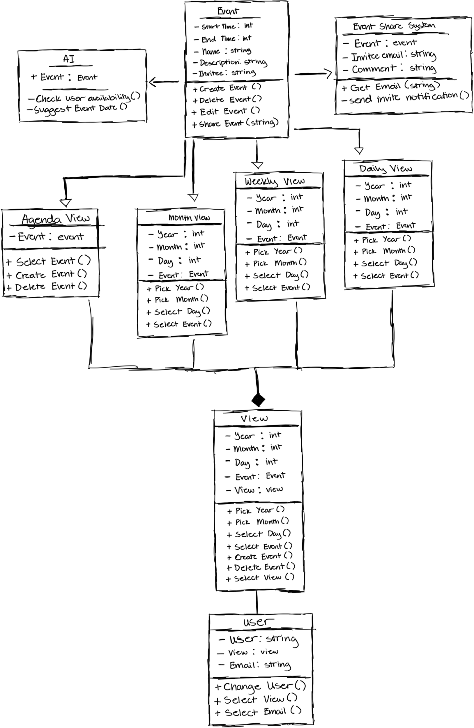

Use Case Diagram:

Problem:

* Lacks relationships (extends/includes).
* The format wasn’t correct

Solution:

* Added the appropriate relations (extends/includes) to the diagram and used correct shapes and figures.
* 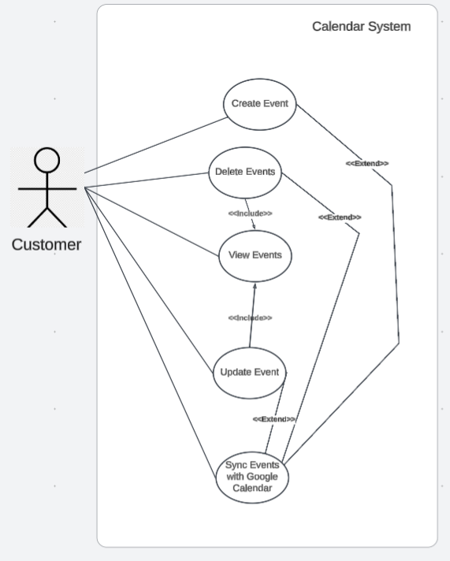

Sequence Diagram:

Problem:

* Each component should be represented only once ( UI, AI ..)
* Use method calls ( example: log in)
* Formatting isn't done properly, and the labels are overlapping.
* Sequence Diagrams: No error paths (example: What if Google Calendar API is unavailable?) - Add alternate flows for failures

Solution:

* Deleted all the duplicate components at the bottom
* Changed from “log in” to method call “login()”
* Fixed the overlapping issue by moving the sequence bar to the bottom, so the text is on top
* Created error paths

